Trebuchet

Subject: Physics, Science  Related Subjects: Mechanical Engineering | Grade Level(s): All Grades  Length of Lesson: 60 Minutes | Type: Project  Keywords: Force, Leverage, Projectile Motion

Lesson Overview
Design and build a small-scale trebuchet using basic materials to launch a projectile as far as possible. This hands-on activity teaches principles of physics, engineering, and mechanical design while encouraging creativity and problem-solving.

Lesson Focus
How can we design a trebuchet to launch a projectile the greatest distance using principles of force, leverage, and motion?

Lesson Objective(s) | By the end of this lesson, students will…  - Design and build a trebuchet with constraints.  - Test their designs and analyze the results of their tests.  - Communicate their design process and results.  - Create instructions on replicating their design.

Lesson Timing

5 minutes | Introduction & goal setting
10 minutes | Review materials and design ideas
30 minutes | Build the trebuchet
10 minutes | Test & adjust
5 minutes | Reflection and wrap-up

Materials | - Cylinder  - Wooden dowel  - Hot glue gun  - Counterweight (cup with 9 oz of rocks)  - Projectile (cork)  - String
Instructor Prep | Step 1: Gather all materials and set up a demonstration or visual reference of a trebuchet. Review safety protocols for using hot glue guns. Print or project example designs for inspiration.
Related Resources | - MESA Day Trebuchet Contest  - Trebuchet Design & Build Challenge - Activity - TeachEngineering  - The Trebuchet - USC Viterbi School of Engineering

Lesson Plan

Introduction
Begin with an engaging question: "How did medieval engineers hurl objects hundreds of feet without electricity or engines?"
Introduce trebuchets as an early engineering marvel. Discuss real-world applications of catapult mechanisms today (e.g., aircraft carriers, amusement park rides). Connect to STEM careers in mechanical engineering and design.

Procedure
- Review Constraints:
- Pivot point max height: 8 inches
- Max counterweight height: 12 inches
- Design Phase:
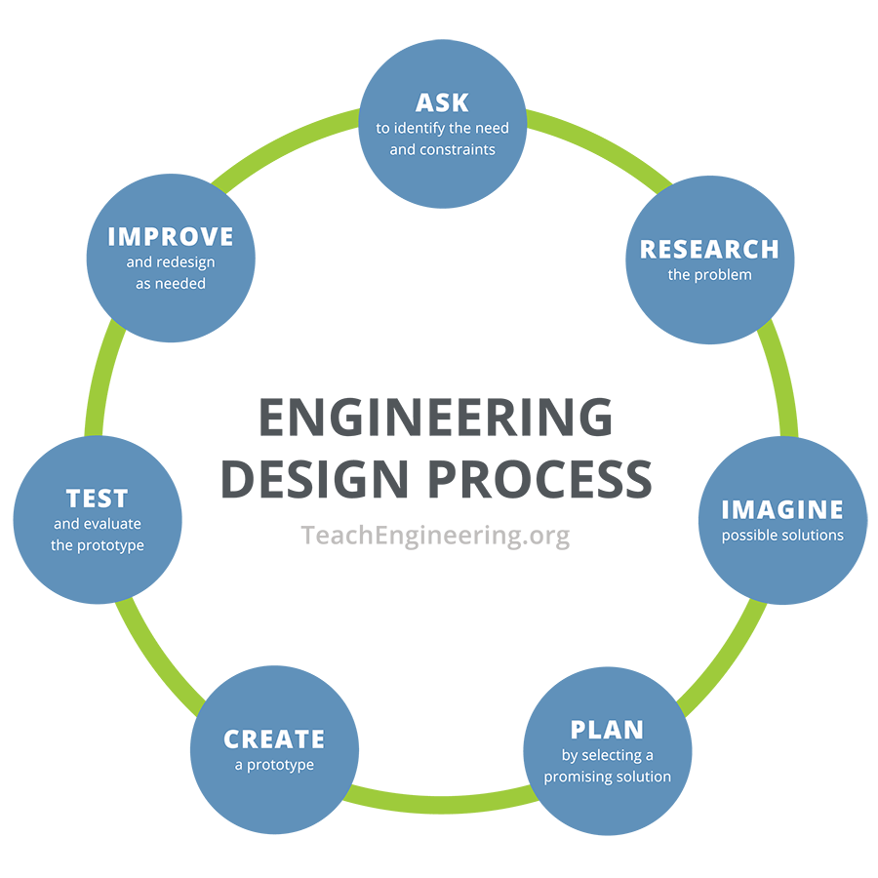
- Sketch possible trebuchet designs in teams
- Discuss force, leverage, and counterweight use
- Build Phase:
- Use dowels, glue, and cylinder to assemble frame
- Add string and counterweight
- Attach projectile arm and test movement
- Test Phase:
- Launch cork
- Measure distance and analyze performance
- Reflection:
- What design changes would improve distance?
- What worked well?
- How did physics play a role in success/failure?
Some examples of trebuchet designs include:
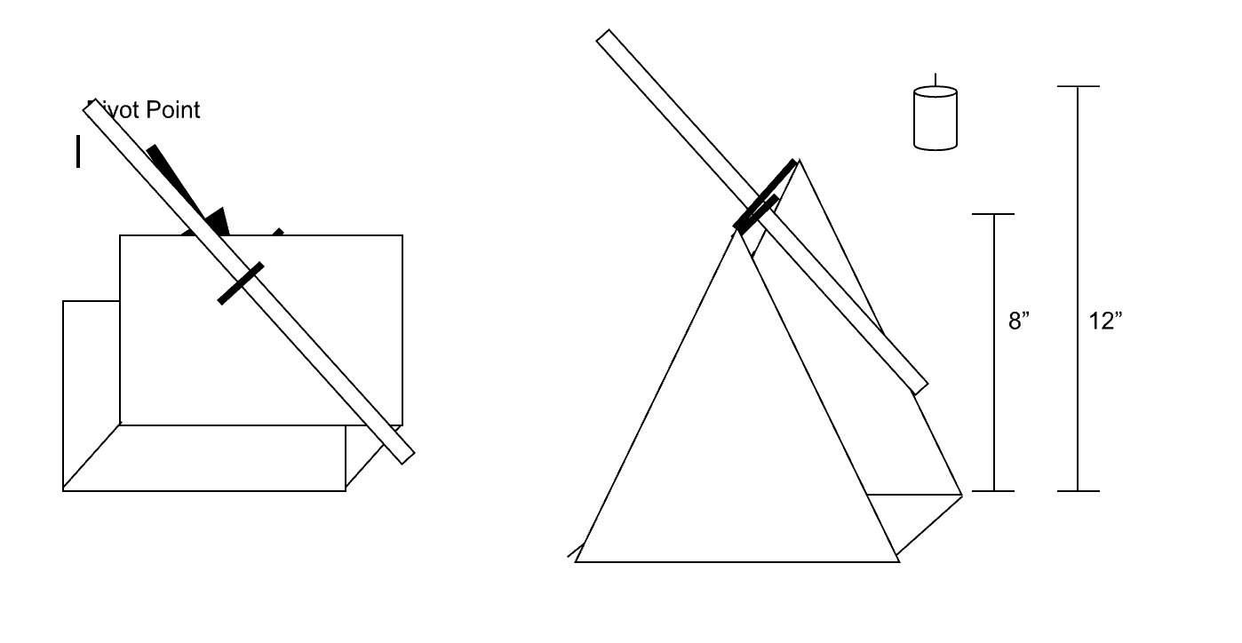

Wrap-up
- Student Reflections:
- Ask students to share one thing they learned from the activity and one thing they would change if they were to build the trebuchet again.
- Have students explain the role of physics in the project (e.g., how gravity and force helped propel the projectile).
- Classroom Discussion:
- Prompt a discussion on what aspects of the trebuchet design had the most significant impact on its success (e.g., counterweight mass, pivot height).
- What modifications could be made to improve performance? Would a bigger counterweight or longer arm increase the distance further?
- Takeaway:
- Provide students with a handout or summary on how simple machines like levers and pulleys contribute to larger mechanical systems in the real world (e.g., bridges, cranes).
- Encourage students to think about how their problem-solving process in building a trebuchet could be applied to other engineering challenges, such as designing sustainable machines or improving urban infrastructure.
Cleanup Note: Ensure hot glue guns are unplugged and cooled. Collect and store all reusable materials.

Lesson Background for Teachers

Suggested Real-World STEM Connections

Dr. Aprille Ericsson

Field: Aerospace Engineering
Contribution: First African-American woman to receive a Ph.D. in Mechanical Engineering from NASA’s Goddard Space Flight Center.
Connection: Designs systems for flight dynamics and payload deployment, akin to trajectory and balance in trebuchets.

- Discuss how trebuchets and similar mechanisms have influenced modern engineering. Examples include catapults in ancient warfare, water launchers in agriculture, or rotating mechanisms in modern engineering (e.g., cranes).

Lesson Variations and Options
- Use rubber bands instead of string for alternative launching methods
- Time-based challenge: shortest time to assemble a working trebuchet
- Incorporate math by calculating projectile angles and distances

Explanation
This lesson leverages mechanical advantage, gravitational potential energy, and lever systems. Trebuchets convert the potential energy of the counterweight into kinetic energy of the projectile. Students explore how variations in arm length, pivot placement, and counterweight mass affect motion and range.

Key Concepts and Vocabulary
- Lever: A rigid bar that rotates around a pivot point to move an object
- Counterweight: A weight that provides force to launch the projectile
- Projectile Motion: The curved path an object follows when thrown or launched

Safety Notes
- Caution students when using hot glue guns—glue can burn skin
- Ensure all projectiles are launched in a safe direction

